**Face Recognition & Expression Recognition Mobile App for Visually Impaired Person**

**Problem Statement**

Approximately 285 million people worldwide are visually impaired One of the most difficult tasks faced by the visually impaired is identification of people. Visually impaired people are unaware of dangers in front of them, even in familiar environments, in unfamiliar environments; such people require guidance to reduce the risk of bumping with obstacles. Voice recognition is a common method of identification; it is an intuitive and difficult process. The rise of computation capability of mobile devices gives motivation to develop applications that can assist visually impaired persons and give them a better life. In this research, the design and implementation of a face detection and recognition system for the visually impaired through the use of mobile computing and deep learning is proposed also a wearable face recognition system for individuals with visual impairments is proposed. This mobile system is assisted by a server based support system. The challenges of the system lie in better recognition techniques for difficult situations in terms of lighting and weather. Due to the limitation of energy on mobile devices, implementation of a face detection and recognition system based on convolutional neural networks(CNN) that provides detection and recognition services to mobile devices with low hardware specifications is proposed.

**Background**

Automated face recognition has been the focus of extensive research for the past four decades. The approaches for this task can be broadly divided into two categories: 1) Feature-based methods which first process the input image to extract distinctive facial features, such as the eyes, mouth, nose, etc., as well as other fiducial marks and then compute the geometric relationships among those facial points, thus, reducing the input facial image to a vector of geometric feature. 2) Appearance-based (or holistic) methods, which attempt to identify faces using global representations, i.e., descriptions based on the entire image rather than on local features of the face. Several alternate sensing technologies such as RFID, infrared and sonar have also been used either on their own or in conjunction with computer vision to aid the visually impaired. Object detection is the process of locating objects in a given environment like cars, faces, people, and landmark. This process involves research approaches like detecting a barcode based system, by presence of doors, Appearance based methods use techniques such as edge detection and histograms to perform detection, using spatial histogram features to represent objects. Some examples of features used in object detection and recognition are the BoW model, Haar-like, LBP, SIFT and SURF. Face recognition uses a Linearly Approximated Sparse Representation-based Classification (LASRC) algorithm, Sparse Representation Classification (SRC) algorithm, Principal Component Analysis (PCA), face recognition system using multi resolution feature fusion. Object detection system also needed, also some mobile applications are present on the Apple Store, Google Play and Windows Phone Store.

**Methodology**

**Step 1: Data collection and dataset preparation**

This will involve collection of Images captured using a high-resolution camera and those captured using a smartphone, FERT dataset, ImageNet dataset will be used then the input data is processed into a set of features before becoming suitable inputs for ,convolutional neural networks(CNN) based face recognition and expression recognition system.

**Step 2: Developing a Face Detection and Recognition System for the Visually Impaired Through the Use of Mobile Computing and Wearable Device**

In this step Face detection, Face recognition, expression recognition using Cascade Classifier, and convolutional network expression recognition system, android mobile app is developed for the smartphone based system to achieve proposed objective also one wearable device is developed.

**Step 3: Training and experimentation on datasets**

The convolutional neural networks based face recognition and expression recognition system will be trained on the dataset and images received real time to do face recognition and expression recognition accurately and notify visually impaired persons on time.

**Step 4: Deployment and analysis on real life scenario**

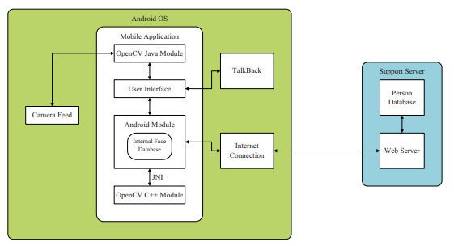

(a)

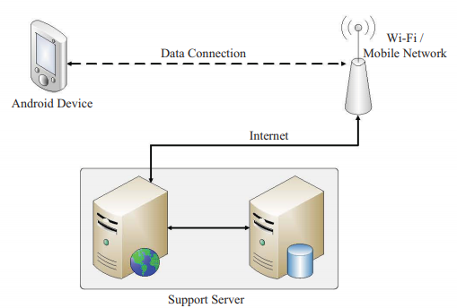

(b)

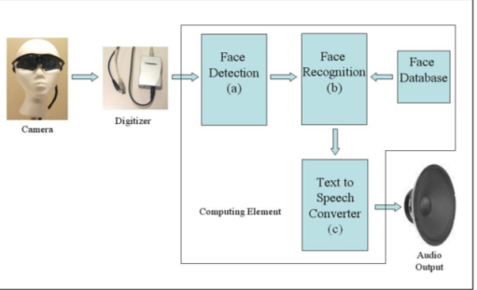

(c)

Figure 1 (a) Face recognition system software framework (b) Design of the proposed face recognition & expression recognition mobile app for visually impaired person [Chaudhry, Shonal, and Rohitash Chandra. "Design of a mobile face recognition system for visually impaired persons." arXiv preprint arXiv:1502.00756 (2015).](c) Block diagram of the wearable face recognition system[S. Krishna, G. Little, J. Black, and S. Panchanathan, "A wearable face recognition system for individuals with visual impairments," in Proceedings of the 7th international ACM SIGACCESS conference on Computers and accessibility, Baltimore, MD, USA, 2005, pp. 106-113]

The trained and tested face recognition and expression recognition model and device will be deployed in a real-life scenario to detect and recognize faces and expressions & will be leveraged for further improvement in the methodology and will follow the above architecture.

**Experimental Design**

**Dataset**

FERET dataset (<http://www.face-rec.org/databases/>), ImageNet dataset, Images are captured using a high-resolution camera and those captured using a smartphone will be used for experimentation and evaluation**.**

**Evaluation Measures**

Measures such as Mean Average Precision, Battery, Processing Power and Memory, Data Usage, Accuracy, Reliability, Number of recognition of obstacle types, Process Speed, Spend time to transmit image to server are used for face recognition & expression recognition mobile app for visually impaired person.

**Software and Hardware Requirements**

Python based Computer Vision and Deep Learning libraries will be exploited for the development and experimentation of the project. Tools such as Anaconda Python and libraries such as Tensorflow, OpenCV and Keras will be utilized for this process. Android device, Mobile Application, Images using a camera and from a smartphone will be needed. Training will be conducted on NVIDIA GPUs for training the above proposed system that contains smartphone-based guiding system for Face recognition & expression recognition for visually impaired people.